SIMATS ENGINEERING (SAVEETHA SCHOOL OF ENGINEERING)

Department of Computer Science and Engineering

CO1 ASSESSMENT TOOL 1 – Case Study Analysis

Course Code: | CSA1005 | Course Title: | Software Engineering
CO Assessed: | CO1 | Assessment: | Assessment Tool 1 – Case Study Analysis
Weightage: | 20% | Total Marks: | 25
CO1 Statement: | Apply advanced methodologies and agile project management techniques to manage software projects effectively
Student Name: | S.Adhikesavan | Reg. No.: | 192521172
Date: |  | Duration: | 60 minutes

Code of Conduct

I S.Adhikesavan – 192521172 (Name / Reg No) certify that this submission is my original work and that I have adhered to the guidelines specified for this assessment. I understand that any violation of academic integrity rules will result in disciplinary action.

Signature of the Student: S.Adhikesavan

1.1 The Problem in Our Own Words
Many patients need care that continues after a single visit: a review after surgery, a repeat blood test, a medication check, or regular monitoring of a long-term condition such as diabetes or hypertension. Hospitals and clinics usually track these follow-ups by hand, using paper registers, spreadsheets, phone calls and memory. As patient numbers grow, this approach breaks down. Patients forget or never get reminded and miss appointments. Lab or scan results arrive but no one confirms that the right doctor has seen them. Staff cannot tell at a glance which patients are overdue, which tests are still pending, and who is responsible for the next step.
The result is delayed care, avoidable complications, wasted doctor time on empty appointment slots, and heavy administrative effort. The problem is therefore to build a single, secure, centralised software system that knows what follow-up each patient needs, reminds the patient at the right time, tracks every pending consultation and diagnostic activity until it is closed, and lets authorised staff coordinate through assigned tasks and secure messages, while protecting sensitive health data.
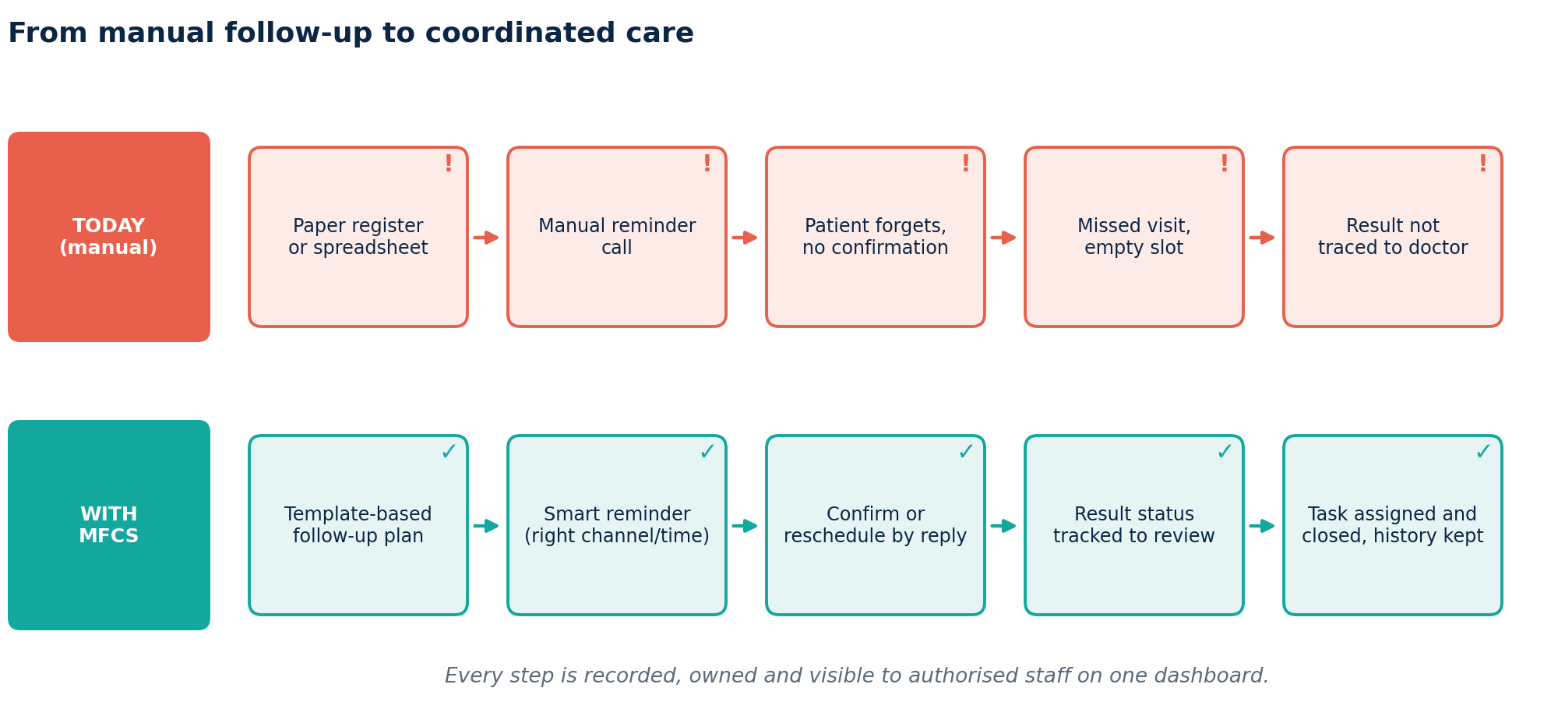
Figure 1: Problem at a glance: manual follow-up versus the proposed coordinated process

1.2 Objectives of the Proposed System
- O1: Maintain configurable follow-up schedules for each patient.
- O2: Track upcoming consultations and their status (scheduled, confirmed, completed, missed, rescheduled).
- O3: Record and track pending diagnostic activities from order to result review and patient communication.
- O4: Generate configurable reminders (channel, timing, language) for patients and authorised staff.
- O5: Track completion of every follow-up activity so nothing is silently dropped.
- O6: Assign care-coordination tasks to staff with priorities, due dates and status.
- O7: Provide role-based dashboards that show overdue, pending and at-risk items.
- O8: Maintain complete, tamper-evident follow-up histories.
- O9: Generate care-coordination reports for management and quality review.
- O10: Protect patient privacy through strict access control, encryption and audit logging.

1.3 Scope of the Problem

In scope
- Patient follow-up plans built from clinical templates and editable per patient
- Appointment tracking and rescheduling
- Diagnostic order and result-status tracking (status only; the system does not interpret results)
- Reminder engine for SMS, email, WhatsApp and app notifications
- Task assignment, secure care-team messaging and notifications
- Role-based dashboards, follow-up history and audit trail
- Reports (PDF/CSV) on missed appointments, turnaround times and workload
- AI features that assist staff: no-show risk scoring, reminder timing, priority ranking, drafting of patient messages
- Integration with existing hospital systems through standard interfaces such as HL7 FHIR

Out of scope
- Clinical diagnosis, treatment recommendations or automated clinical decisions (all clinical decisions stay with clinicians)
- Billing, insurance claims and pharmacy inventory
- Full electronic health record replacement
- Telemedicine video consultation (possible future enhancement)
The system is intended for hospitals, multi-specialty clinics and diagnostic centres. The pilot is assumed to run in a single clinic before wider rollout.

2. Key Stakeholders and Challenges

2.1 Stakeholders, Roles and Responsibilities
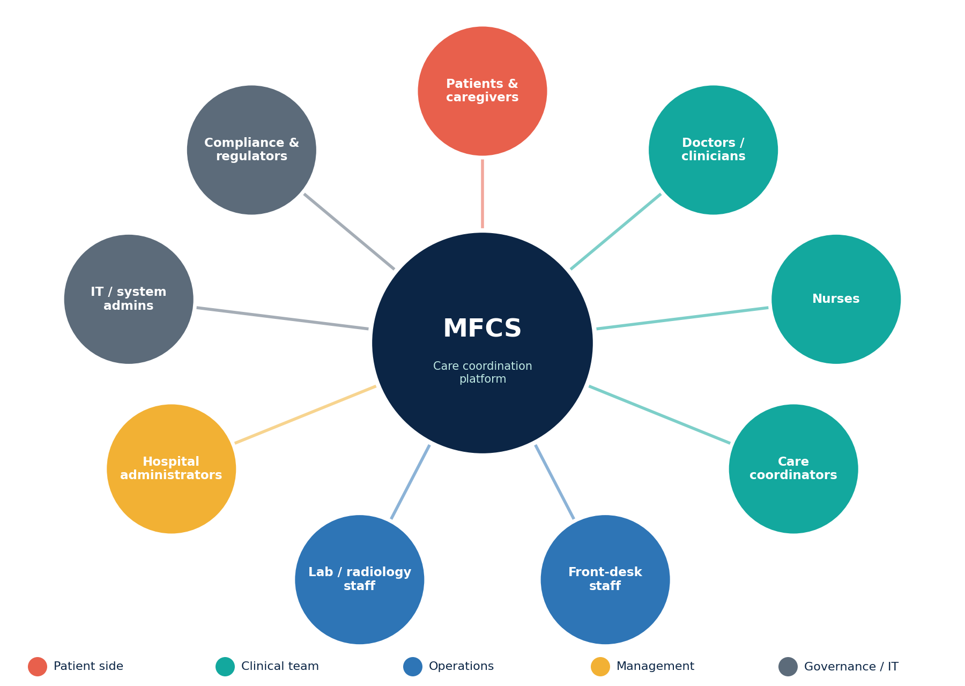
Figure 2: Stakeholder map of the MFCS ecosystem
Stakeholder | Role and responsibilities | Interest in the system
Patients and caregivers | Attend appointments, complete tests, take medication as advised, respond to reminders, give consent for communication | Timely reminders, easy rescheduling, privacy, understandable messages
Doctors / Clinicians | Order follow-ups and tests, review results, make all clinical decisions, confirm AI-suggested priorities | Quick view of pending results and high-risk patients, less paperwork
Nurses | Monitor patients, carry out medication reviews, call patients, update follow-up status | Clear task lists, easy status updates
Care coordinators | Own the follow-up process: chase missed appointments and results, assign and close tasks | Central dashboard, overdue alerts, workload visibility
Front-desk / reception staff | Book and reschedule appointments, register patients, handle walk-ins | Simple scheduling, fewer phone queries
Laboratory / radiology staff | Update sample, scan and result status; report abnormal findings | Direct result updates, no duplicate data entry
Hospital administrators / management | Define policies and templates, monitor performance and resource use, ensure compliance | Reports, KPIs, reduced no-shows and cost
IT / system administrators | Deploy, secure, back up and maintain the system; manage users and integrations | Stable, secure, maintainable platform
Compliance / privacy officer | Ensure legal and ethical handling of data; review audit logs | Audit trails, consent records, regulatory conformity
Regulators and external systems | Data-protection authorities (e.g., DPDP Act 2023), ABDM, EHR/LIS vendors | Lawful data handling, interoperable standards

2.2 Major Challenges Faced by Stakeholders
Stakeholder | Challenges and issues
Patients | Forgetting appointments; unclear instructions; language barriers; difficulty rescheduling; worry about who can see their data; travel distance and cost.
Doctors | Result reports arrive late or get lost; no easy way to see which of their patients have missed follow-ups; time lost to administrative tracking.
Nurses and coordinators | Manual calling is time-consuming; unclear ownership of tasks; no way to prioritise urgent cases; difficulty tracking dozens of patients at once.
Front desk | Double booking, schedule changes by phone, many repetitive enquiries.
Lab staff | Results sent on paper or by phone; unclear whether the clinician has acknowledged an abnormal result.
Management | No consolidated data on missed appointments, turnaround times or staff workload; revenue loss from empty slots.
IT and compliance | Securing sensitive data, integrating with legacy systems, avoiding unauthorised access, meeting legal obligations, maintaining audit evidence.

Cross-cutting challenges include data privacy, alert fatigue (too many notifications), poor integration between departments, varied digital literacy among patients and staff, and unreliable connectivity in some regions.

Key insight
Across every stakeholder the same root cause appears: nobody owns the whole follow-up loop. Nothing connects the plan, the reminder, the result and the responsible person, so failures stay invisible until the patient is harmed or lost to care.

3. Analysis of the Current Approach

3.1 Existing Process
In most small and mid-sized healthcare facilities, the follow-up process works as follows:
- The doctor tells the patient verbally or writes on a prescription when to return.
- A receptionist or nurse notes the date in an appointment register, a spreadsheet or the basic scheduling module of the hospital software.
- Reminders, if any, are given by manual phone calls or ad-hoc SMS messages on the day before the visit.
- Diagnostic tests are ordered on paper; the lab returns a printed report or a phone call. Someone must remember to check whether the result has come back.
- Coordination between staff happens through phone calls, informal messaging groups or verbal hand-offs.
- Management receives occasional manual counts of missed appointments, if at all.

3.2 Strengths and Limitations
Strengths of the current process | Limitations of the current process
Simple, familiar and requires little training | Highly dependent on individual memory and diligence
Low upfront cost; no new technology | No central view; information scattered across registers, sheets and chats
Personal contact by phone can build trust | Manual reminders do not scale and are inconsistent
Flexible for exceptional cases | No tracking of pending diagnostics or accountability for results
Paper records are not exposed to online attacks | Weak privacy: shared spreadsheets and messaging apps lack access control and audit trail
 | No analytics, so problems cannot be measured or improved

3.3 Problems and Gaps to Be Addressed
- Missed follow-ups: No systematic, timely, multi-channel reminders; no identification of patients likely to miss visits.
- Lost or delayed results: No status tracking from test order to clinician review and communication to the patient.
- No task ownership: Follow-up actions are not assigned, prioritised or tracked to completion.
- Poor visibility: No dashboard that shows overdue and at-risk activities for each role.
- Fragmented history: No consolidated, reliable follow-up history per patient.
- Privacy and compliance gaps: Unrestricted access to patient data, no audit trail, informal sharing over messaging apps.
- No reporting: Management cannot measure no-show rates, turnaround time or workload.
- Poor integration: Duplicate data entry between EHR, lab system and scheduling tools.

4. Proposed Solution Using Software Engineering Principles

4.1 Solution Overview
We propose a web-based, role-driven platform called the Medical Follow-Up and Care Coordination System (MFCS). It acts as a coordination layer on top of existing hospital systems: it holds follow-up schedules, tracks every pending appointment and diagnostic activity, sends reminders, assigns tasks and gives staff a unified dashboard. An AI service supports staff by predicting no-show risk, choosing reminder timing, ranking urgency and drafting patient-friendly messages. The AI only suggests and prioritises. It never diagnoses or recommends treatment, and clinicians confirm every clinical decision.
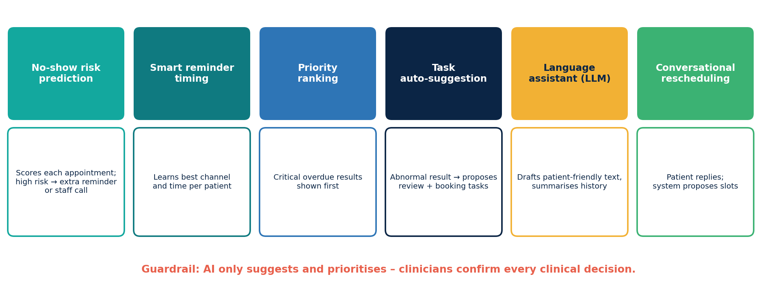
Figure 3: AI-assisted capabilities of MFCS (advisory only)

4.2 High-Level Architecture
The system follows a layered, service-oriented architecture:
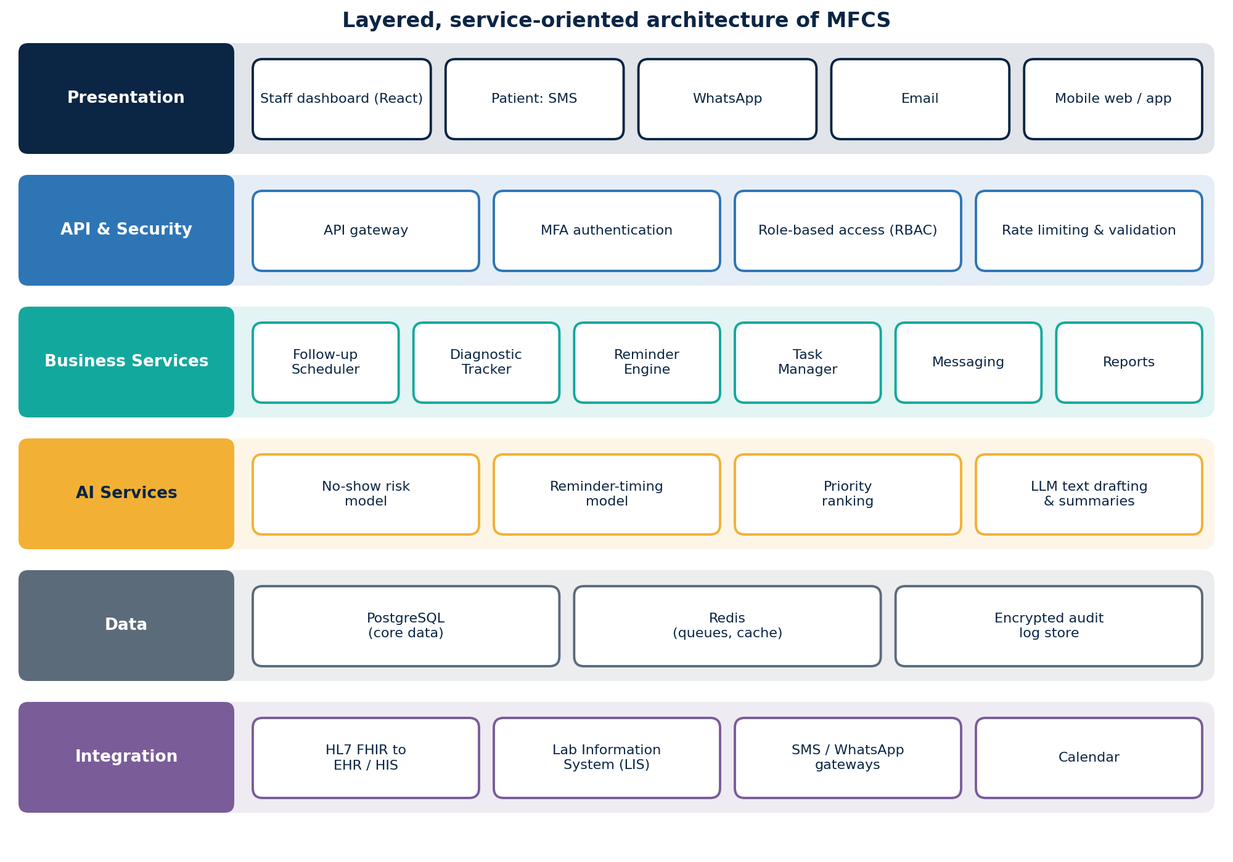
Figure 4: Layered architecture of MFCS
Layer | Components
Presentation layer | React-based responsive staff dashboard; patient channels (SMS, WhatsApp, email, mobile web/app)
API and security layer | API gateway, authentication (MFA), role-based access control, rate limiting, input validation
Business services layer | Follow-up Scheduler, Diagnostic Tracker, Reminder Engine, Task Manager, Messaging, Reporting, Audit service
AI service layer | No-show risk model, reminder-timing model, priority ranking, LLM-based text drafting and summarisation
Data layer | PostgreSQL (core data), Redis (queues and caching), encrypted audit log store
Integration layer | HL7 FHIR interfaces to EHR/HIS and Lab Information System, notification gateways, calendar services

Suggested technology stack: React (frontend), FastAPI or Node.js (backend), PostgreSQL, Redis with Celery for scheduled jobs, Twilio or a local SMS/WhatsApp gateway, scikit-learn/XGBoost for risk scoring, and an LLM API for text generation.

4.3 Major Functional Modules
Module | Description | Objective served
Patient and Consent Management | Patient profile, contact details, preferred channel and language, consent for communication | O1, O4, O10
Follow-up Scheduler | Configurable templates (e.g., post-surgery: day 7, 30, 90; diabetes: HbA1c every 3 months) that generate editable follow-up plans; handles booking and rescheduling | O1, O2
Diagnostic Tracker | Tracks each order through Ordered, Sample/Scan Done, Result Pending, Result Received, Reviewed by Clinician and Communicated to Patient | O3, O5
Reminder Engine | Configurable timing (e.g., 7 days, 1 day, 2 hours before), channel, language and escalation rules; records delivery and replies | O4
Task Manager | Create, assign, prioritise and close tasks (call patient, chase report, medication review); auto-suggested tasks from events | O5, O6
Care-Team Messaging | Secure patient-linked message threads between authorised staff | O6, O10
Dashboards | Role-based views: today's appointments, overdue items, pending results, at-risk patients | O7
History and Audit | Chronological timeline of all follow-ups, reminders, tasks and messages; immutable audit log | O8, O10
Reports and Analytics | Missed-appointment rate, result turnaround, task completion, workload per staff member; export to PDF/CSV | O9
AI Assistant Service | No-show prediction, smart timing, urgency ranking, text drafting, conversational rescheduling | O2, O4, O7
Administration | User and role management, template configuration, system settings | O10

Diagnostic result tracking workflow
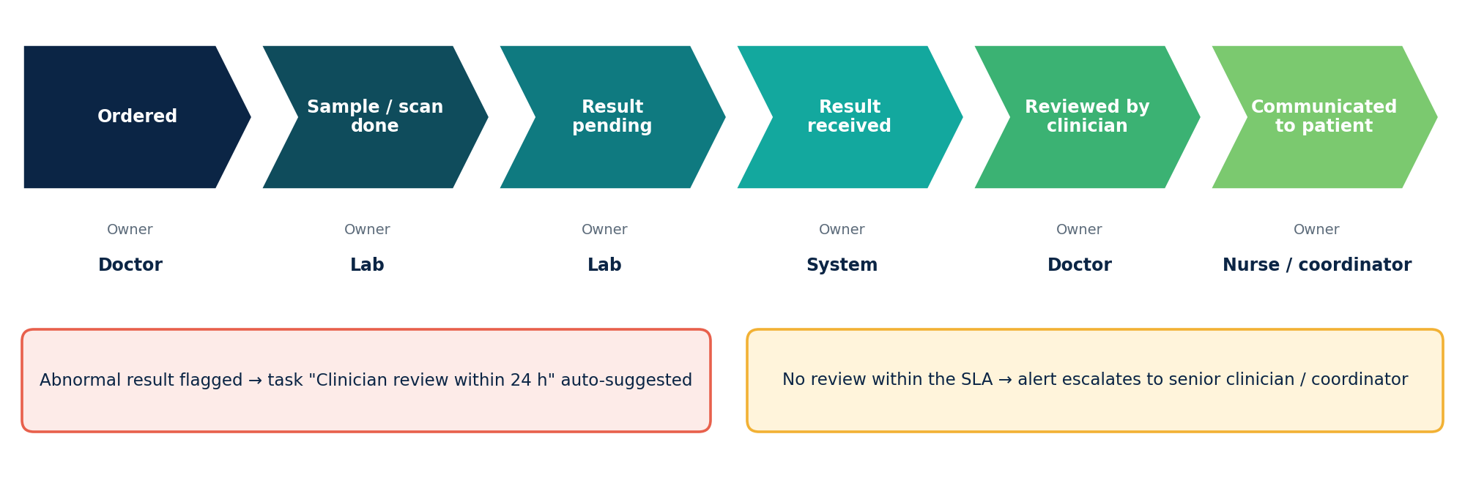
Figure 5: Lifecycle of a diagnostic order, with escalation rules

Illustrative staff dashboard
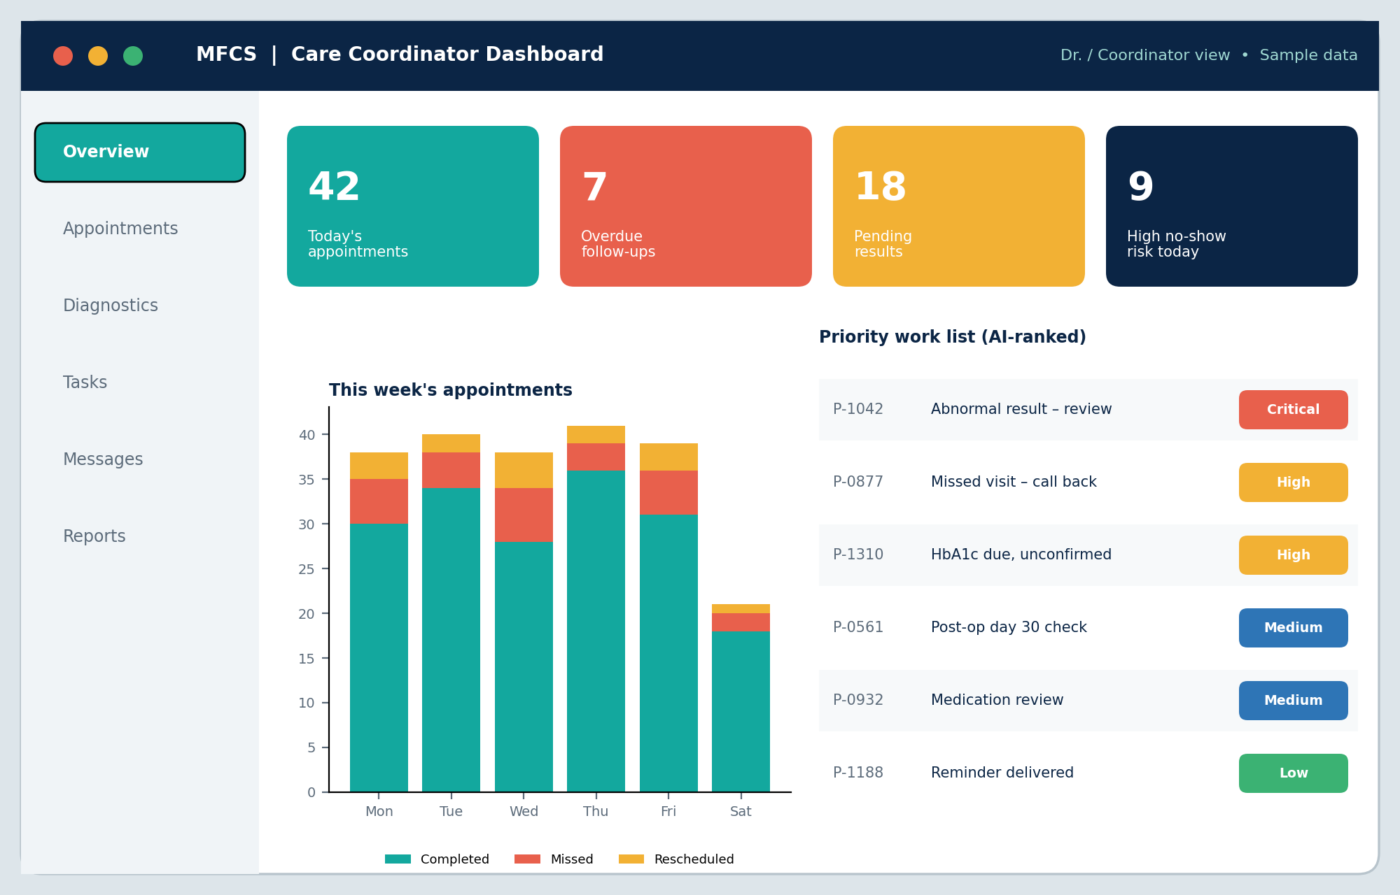
Figure 6: Mock-up of the care-coordinator dashboard (sample data, for illustration only)

4.4 Functional Requirements
- FR1: The system shall allow authorised users to register patients and record contact details, preferred channel, language and consent.
- FR2: The system shall create follow-up plans from configurable templates and allow manual editing per patient.
- FR3: The system shall schedule, confirm, reschedule and cancel appointments and record their outcome (completed, missed).
- FR4: The system shall record diagnostic orders and track each status change with timestamp and user.
- FR5: The system shall flag a result as abnormal/critical and notify the responsible clinician.
- FR6: The system shall send reminders via configurable channels and times, and record delivery status and patient responses.
- FR7: The system shall escalate when a reminder is unanswered or a result is not reviewed within the defined time limit.
- FR8: The system shall allow tasks to be created, assigned, prioritised, reassigned and closed, with due dates.
- FR9: The system shall provide secure messaging between authorised care-team members, linked to a patient record.
- FR10: The system shall display role-specific dashboards with filters for overdue, pending and high-risk items.
- FR11: The system shall maintain a complete follow-up history for each patient.
- FR12: The system shall generate and export care-coordination reports.
- FR13: The system shall authenticate users with MFA and enforce role-based and care-team-based access.
- FR14: The system shall log every view, edit, export and message in an audit trail.
- FR15: The system shall provide AI-generated no-show risk scores, task suggestions and draft messages that require staff confirmation.
- FR16: The system shall exchange data with EHR and laboratory systems through HL7 FHIR APIs.

4.5 Non-Functional Requirements
Category | Requirement
Performance | Dashboards load within 3 seconds for typical queries; reminders dispatched within 1 minute of their scheduled time.
Scalability | Supports growth from one clinic to multiple hospitals (at least 100,000 active patients) through horizontal scaling of stateless services.
Availability and reliability | Target 99.5% uptime; automatic retry of failed notifications; daily backups with tested recovery (RPO 24 hours or less, RTO 4 hours or less).
Security | TLS 1.2+ in transit, AES-256 at rest, field-level encryption for diagnoses and results, MFA, session timeouts, break-glass access with justification.
Privacy and compliance | Minimum-necessary access; consent management; alignment with HIPAA principles, India's DPDP Act 2023 and ABDM guidelines; reminders carry no clinical details.
Usability | Clean interface with minimal clicks for common tasks; multi-language patient messages; accessible design (WCAG 2.1 AA); training under 2 hours for staff.
Maintainability | Modular code, automated tests with at least 80% coverage on core services, documented APIs, configuration instead of hard-coding.
Interoperability | Standards-based integration using HL7 FHIR and REST APIs.
Auditability | Immutable audit log retained according to policy; searchable by user, patient and date.
Explainability of AI | Each AI score shows its main contributing factors; AI can be disabled without affecting core functions.

4.6 Incorporation of Software Engineering Principles
Principle | How it is incorporated
Modularity | The system is split into independent modules (Scheduler, Diagnostics, Reminders, Tasks, Messaging, Reports, AI) with well-defined APIs and low coupling, so each can be developed, tested and replaced separately.
Scalability | Stateless services behind a load balancer; message queues (Redis/Celery) for reminder bursts; database indexing and read replicas for reports; the AI service can scale independently.
Maintainability | Layered design, clean coding standards, version control, code reviews, CI/CD pipeline, API documentation, and rule/template configuration through the admin screen rather than code changes.
Reliability | Retry and fallback for notification delivery (e.g., SMS if WhatsApp fails), transaction-safe updates, backups, health monitoring, graceful degradation if the AI service is unavailable.
Usability | Role-specific dashboards, colour-coded priorities, simple appointment workflows, patient-friendly language, multi-language messages and mobile-responsive design.
Security | Defence in depth: RBAC, care-team scoping, MFA, encryption, audit trails, secure coding practices, regular penetration tests and de-identified data for AI training.
Separation of concerns and reusability | Business rules, data access and presentation are separated; shared components (notification service, audit service) are reused by all modules.
Testability | Unit, integration, security and user-acceptance tests; mock interfaces for EHR/LIS and messaging gateways.

4.7 Core Data Model
The data model is kept simple and normalised. Every clinical or coordination object links back to a patient and, where relevant, to a care-team member, which makes access control and auditing straightforward.
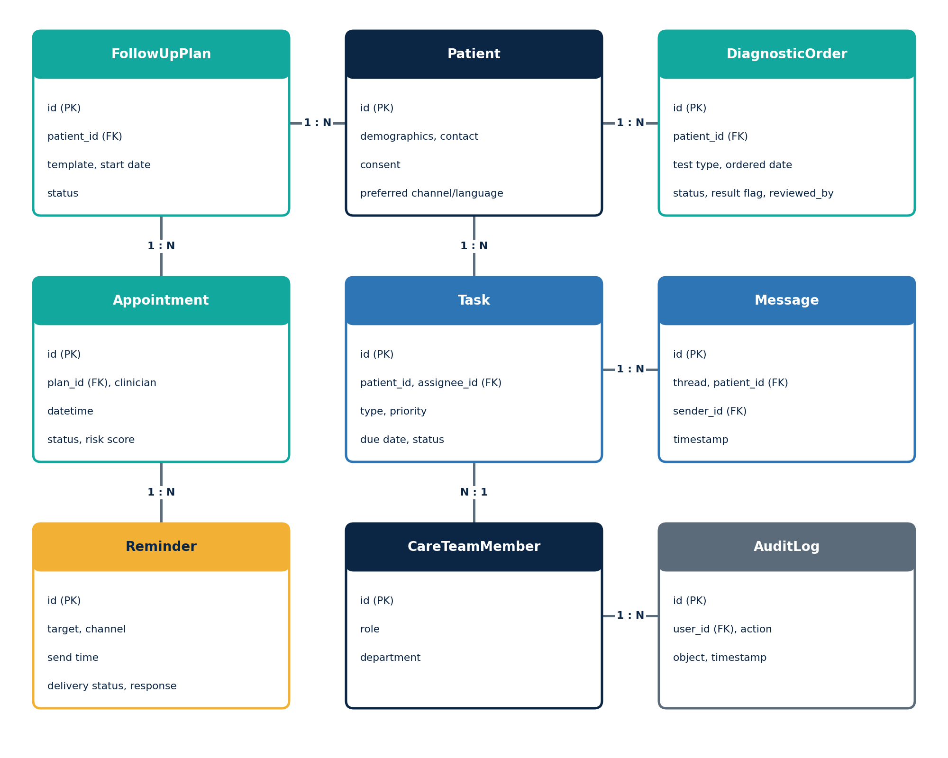
Figure 7: Entity-relationship overview of the core MFCS data model

4.8 Role-Based Access Control Matrix
Access follows the minimum-necessary principle. In the matrix, Edit means view and modify, View means read-only, and a dash means no access. It shows illustrative default permissions; in every case a user can open only the records of patients assigned to their own care team or department.
Data / function | Doctor | Nurse | Coord. | Front desk | Lab | Admin
Demographics, contact | View | View | Edit | Edit | View | -
Appointments | Edit | Edit | Edit | Edit | - | -
Diagnostic order status | Edit | View | View | - | Edit | -
Clinical result details | Edit | View | - | - | Edit | -
Care tasks | Edit | Edit | Edit | View | View | -
Care-team messaging | Edit | Edit | Edit | - | Edit | -
Reports and analytics | View | - | Edit | - | - | Edit
Users and templates | - | - | - | - | - | Edit
Audit logs | - | - | - | - | - | View

5. Justification of the Chosen Methodology

5.1 Selected Framework: Agile (Scrum) with DevOps Practices
We choose the Agile Scrum framework, supported by DevOps practices (continuous integration, continuous delivery, automated testing and monitoring). Development proceeds in 2-to-3-week sprints, each delivering a working increment, with a Product Owner (hospital representative), a Scrum Master and a cross-functional development team.
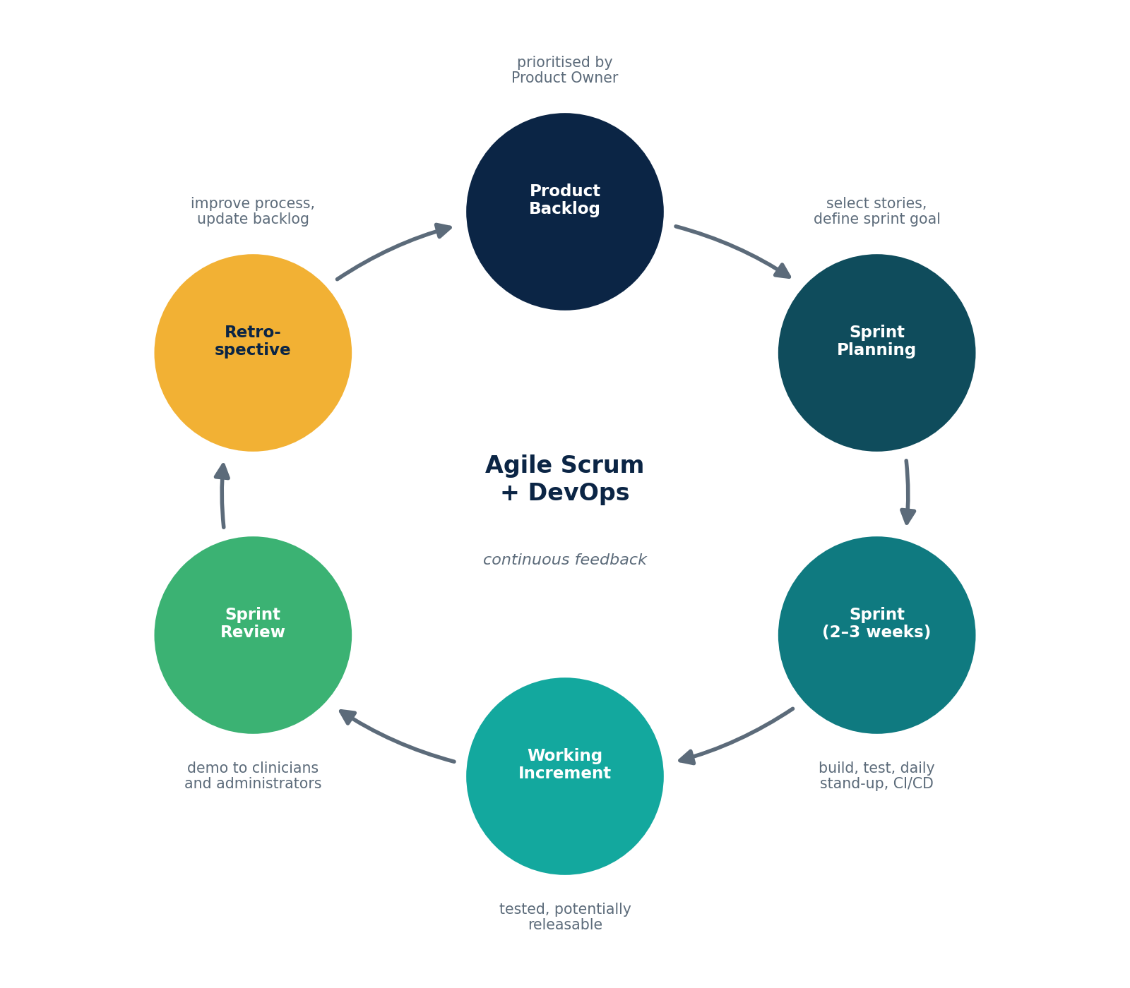
Figure 8: Scrum cycle with DevOps practices for MFCS

5.2 Why It Is Suitable
- Evolving requirements: Clinical workflows differ between departments and clinics. Agile allows requirements to be refined through regular feedback from doctors, nurses and coordinators, which Waterfall cannot easily handle.
- Incremental delivery of value: A usable MVP (patient records, scheduling, rule-based reminders, RBAC, basic dashboard) can reach the pilot clinic early; diagnostics, tasks, messaging, reports and AI follow in later sprints.
- Active stakeholder involvement: Sprint reviews and demos keep clinical staff and administrators engaged, which improves adoption and usability.
- Risk management: Early and frequent releases expose integration, usability and security problems sooner. This is critical for a system handling sensitive health data.
- Suitable for AI components: AI models need experimentation and tuning with real data. Short iterations allow models to be trained, evaluated, and improved gradually, and added only after enough data has been collected.
- Prioritisation: The product backlog can be re-ordered so high-value, safety-related features (such as abnormal-result tracking) come first.

5.3 Comparison with Other Models
Model | Advantage | Why not chosen as the primary model
Waterfall | Clear documentation and phases | Inflexible to changing clinical requirements; users see the product only at the end
Spiral | Strong risk analysis | Heavy and costly for a mid-sized project; Scrum already gives frequent risk review
Pure DevOps | Fast, automated delivery | It is a practice set, not a full planning framework; used here alongside Scrum

5.4 How It Supports Development and Maintenance
- Development: a prioritised backlog, user stories with acceptance criteria, sprint planning, daily stand-ups and retrospectives keep the team aligned and continuously improving.
- Quality: test automation, code review and CI pipelines catch defects early; security and privacy checks are part of the Definition of Done.
- Deployment: CI/CD pipelines and containerisation (Docker) allow safe, repeatable releases and quick rollbacks.
- Maintenance: the same sprint cycle handles bug fixes, regulatory changes, and new feature requests, while monitoring and user feedback feed directly into the backlog.
- Documentation: lightweight but sufficient documentation (API specs, architecture decisions, user guides) is maintained each sprint.

5.5 Proposed Development Phases
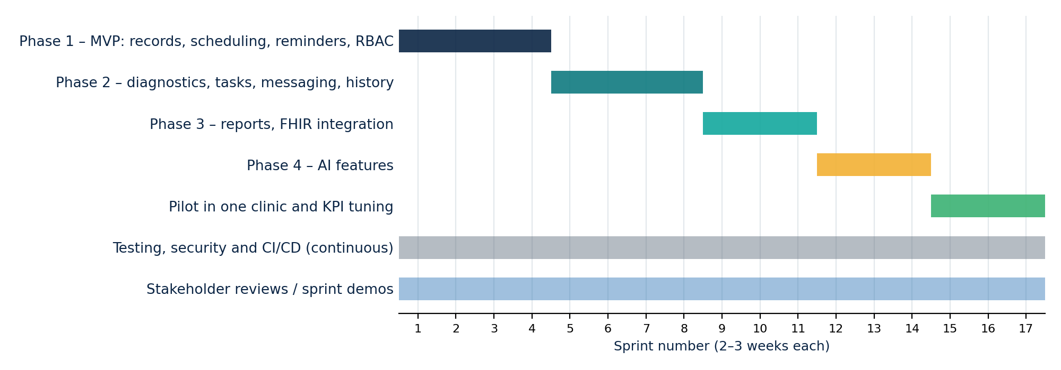
Figure 9: Indicative sprint roadmap (planning assumption: 17 sprints including pilot)
Phase | Deliverables | Indicative duration
Phase 1 (MVP) | Patient records, appointment scheduling, rule-based reminders, RBAC and MFA, basic dashboard | Sprints 1-4
Phase 2 | Diagnostic tracker, task assignment, secure messaging, history timeline | Sprints 5-8
Phase 3 | Reports and analytics, FHIR integration with EHR/LIS | Sprints 9-11
Phase 4 | AI features: no-show prediction, smart timing, priority ranking, NLP assistant | Sprints 12-14
Pilot and rollout | Single-clinic pilot, KPI measurement, tuning, then wider rollout | After Phase 4

6. Expected Outcomes and Limitations

6.1 Expected Benefits
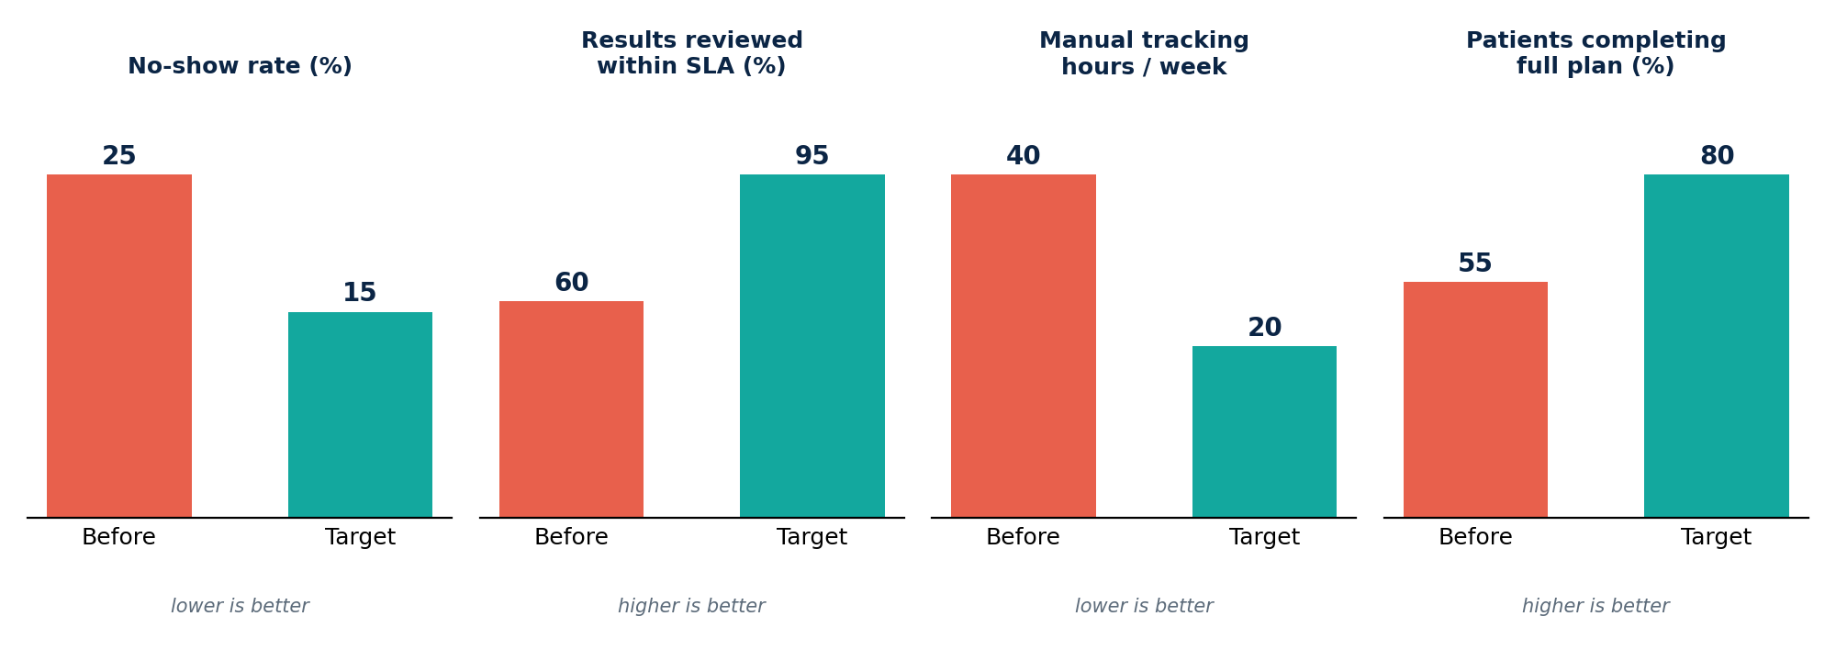
Figure 10: Illustrative targets for the pilot KPIs (planning assumptions, to be validated with real data)
Note on the figures
The before and target values above are planning assumptions used to set measurable goals. They are not results from a deployed system; the pilot phase exists to measure the real baseline and improvement.

Expected outcome | Key performance indicator (KPI)
Reduced missed follow-up appointments | No-show rate before vs. after deployment
Improved coordination among staff | Average task completion time; number of unassigned or overdue tasks
Better visibility of pending activities | Percentage of pending results reviewed within the agreed time limit
Reduced administrative workload | Staff hours spent on manual calls and tracking
Improved continuity of care | Percentage of patients completing their full follow-up plan
More organised follow-up management | Percentage of follow-ups with a recorded owner and status; report availability

6.2 How the Solution Addresses the Identified Challenges
Challenge | Addressed by
Patients forget or miss appointments | Configurable multi-channel reminders, AI-based timing, conversational rescheduling, extra outreach for high no-show risk
Results lost or delayed | Diagnostic Tracker with status stages, escalation and clinician review confirmation
Unclear responsibility | Task Manager with assignee, priority and due date; auto-suggested tasks
No overall visibility | Role-based dashboards and priority ranking
Fragmented history | Consolidated follow-up timeline per patient
Privacy and compliance risks | RBAC, care-team scoping, encryption, MFA, audit logs, consent management
No performance data | Automated reports and KPIs
Duplicate data entry | FHIR integration with EHR and lab systems

6.3 Risks, Implementation Challenges and Limitations
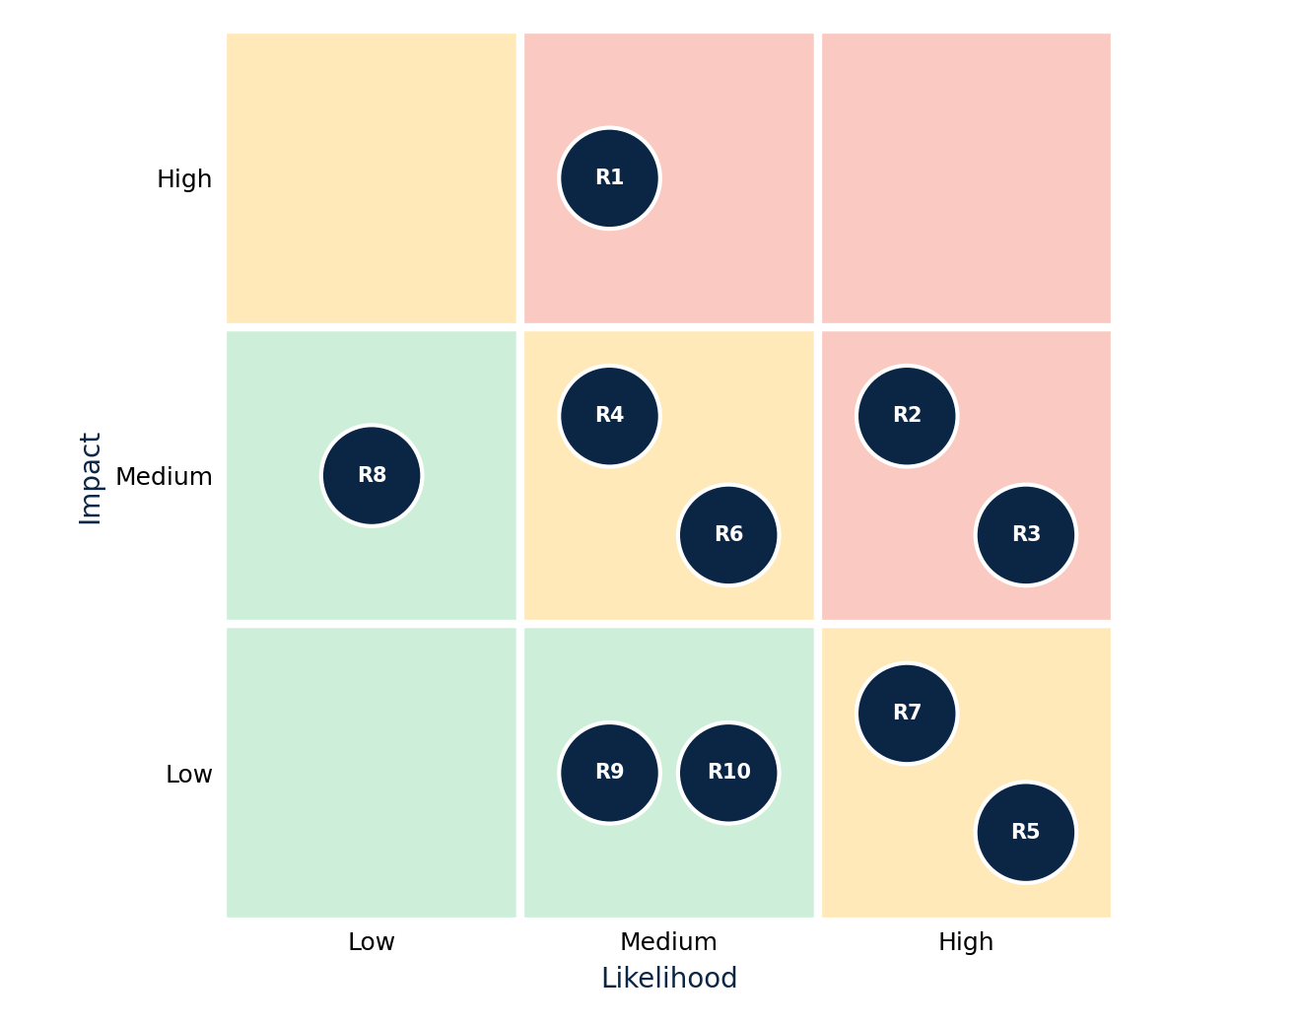
Figure 11: Risk assessment matrix (likelihood versus impact); R1 to R10 follow the order of the table below
Risk / limitation | Description | Mitigation
R1. Data breach or privacy violation | Health data is highly sensitive; breaches harm patients and reputation | Encryption, MFA, audit logging, regular security testing, staff training, incident response plan
R2. Staff resistance to change | Users may prefer existing habits | Early involvement, training, simple UI, champions in each department
R3. Integration complexity | Legacy EHR/LIS may not support FHIR | Adapter layer, phased integration, CSV/HL7 v2 fallback
R4. AI bias and errors | Risk model may be inaccurate or biased for some groups; initial data may be insufficient | Start rule-based; human confirmation; monitor fairness and accuracy; retrain regularly; explainable scores
R5. Alert fatigue | Too many reminders or alerts reduce attention | Configurable thresholds, priority ranking, patient-controlled preferences
R6. Notification failures | SMS or WhatsApp delivery may fail or be delayed | Fallback channels, retries, delivery tracking, staff calls for critical cases
R7. Digital divide | Some patients lack smartphones, internet or literacy | Voice calls, SMS in local languages, assisted contact by staff
R8. Regulatory change | Laws on health data and AI may evolve | Configurable policies, periodic compliance review
R9. Cost and infrastructure | Licensing, hosting, messaging costs and connectivity | Cloud-based scalable hosting, phased rollout, pilot-based cost-benefit evaluation
R10. Dependence on data quality | Wrong contact details or incomplete records reduce effectiveness | Validation at entry, periodic data-cleaning, patient self-confirmation

Limitations: the system supports coordination but cannot ensure that patients actually attend; it does not provide clinical judgement; AI accuracy depends on data volume and quality; and the benefits depend on consistent use by all departments.

6.4 Possible Future Enhancements
- Patient mobile app and portal for self-scheduling, document upload and secure messaging.
- Voice-based IVR and voice-assistant reminders in regional languages.
- Integration with wearables and home-monitoring devices for chronic care follow-up.
- Telemedicine integration so missed visits can be converted to virtual consultations.
- Advanced predictive analytics for readmission risk and care-gap detection, with fairness auditing.
- Federated learning so multiple hospitals can improve models without sharing raw patient data.
- Integration with ABDM health IDs, national health records and insurance workflows.
- Transport and appointment-slot optimisation, and automated waiting-list management.
- Patient feedback and satisfaction analytics.

7. Conclusion
Manual handling of medical follow-ups causes missed appointments, delayed results and fragmented coordination. The proposed AI-Powered Medical Follow-Up and Care Coordination System replaces this with a centralised, secure and modular platform that schedules, reminds, tracks, assigns and reports. By applying software engineering principles of modularity, scalability, maintainability, reliability, usability and security, and by developing it through Agile Scrum with DevOps practices, the project can deliver value early, adapt to clinical needs, and remain maintainable over time. With carefully governed AI that supports but never replaces clinicians, the system can improve continuity of care, reduce administrative burden and give healthcare teams clear visibility of pending patient activities.

8. Standards and Frameworks Referenced
- HL7 FHIR: interoperability standard for exchanging health data with EHR and laboratory systems.
- HIPAA privacy and security principles: minimum-necessary access, audit controls, transmission security.
- India's Digital Personal Data Protection (DPDP) Act 2023 and Ayushman Bharat Digital Mission (ABDM) guidelines.
- The Scrum Guide: roles, events and artefacts used in the development process.
- ISO/IEC 25010 software quality model: basis for the non-functional requirements (reliability, security, usability, maintainability, performance).
- WCAG 2.1 AA: accessibility guideline for the staff and patient interfaces.

Screen Shots :
